Site URL ( Temporary ): <http://conic.ddns.net:8004/>

The main page of the labeler by Go Thailand will be like this ( no login at the moment )

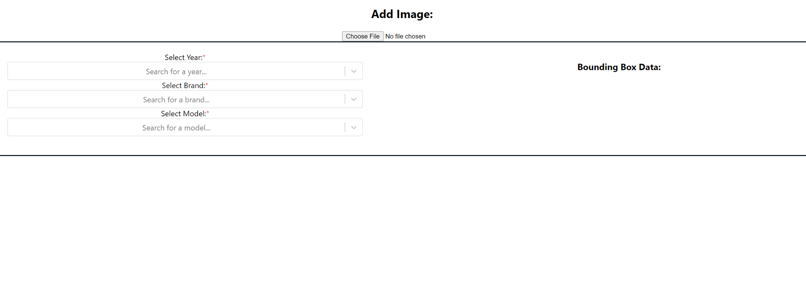

When choosing the File to upload

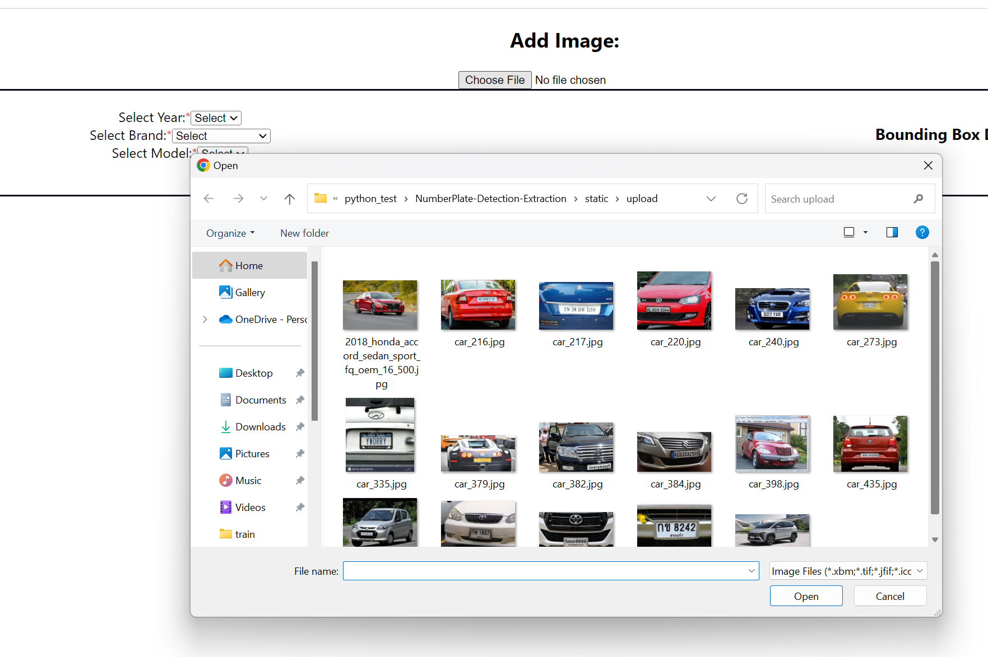

Once the Image is Selected and ready for labeling, you may select the car's details by year, brand, and model.

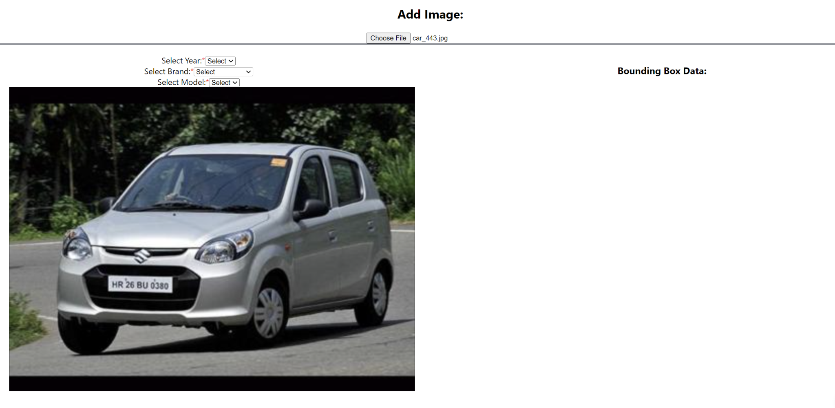

After selecting the specific parts of the vehicle, it will display a colored box and you need to select an option from the prompt.

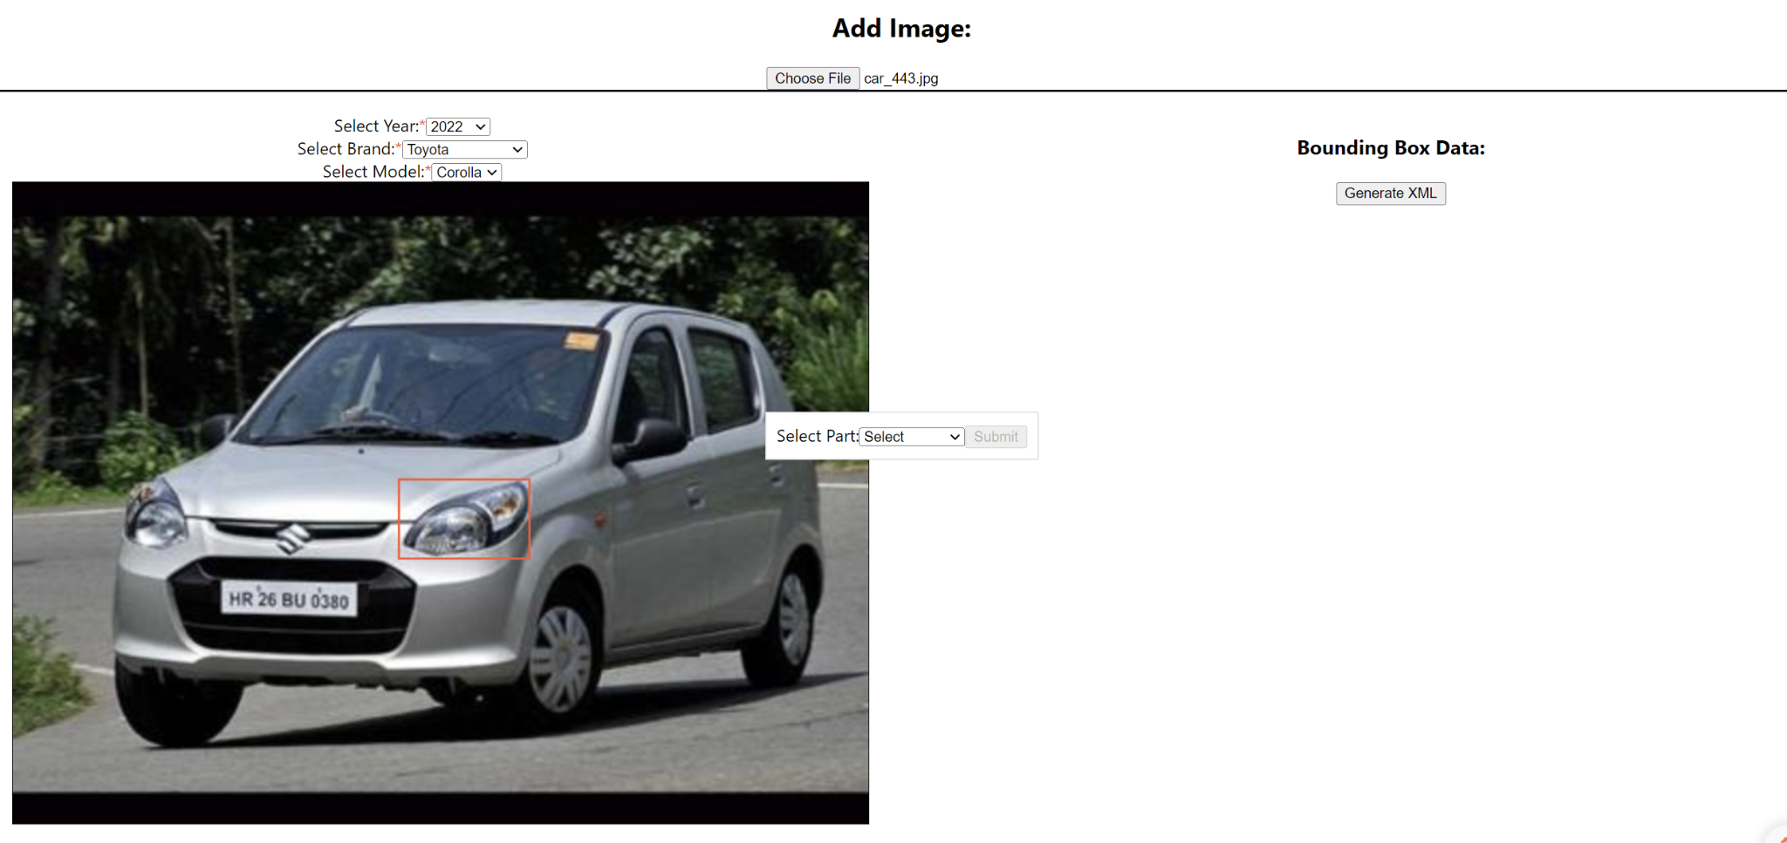

Once you’ve successfully labeled the parts of the Car it will appear like this:

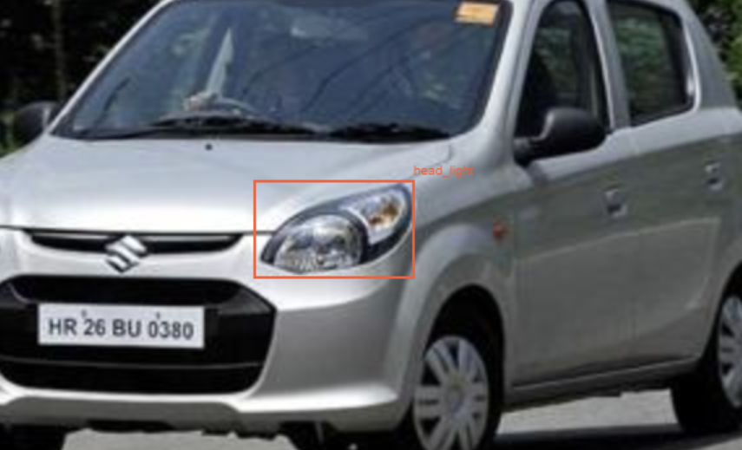

The final output will be something like this:

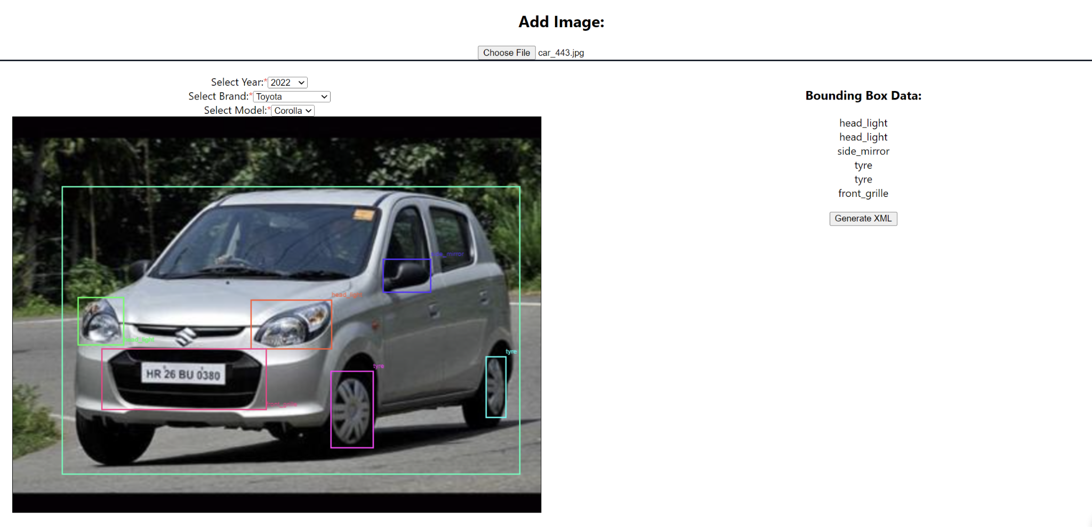

After you successfully labeled all the parts and the car, you have to generate the XML file that is needed for the training and it will generate a sample output similar to the image below once satisfied with the details, you need to hit the upload button.

